Week 4 Homework Report
Name: 张智燊 (Zhang Zhishen) Student ID: SUAT24000210 Date: 2026-09-20 Course: Bioinformatics: From Multi-Omics Data to Discovery
How to read this report. Every question is answered in the four required parts: (1) reasoning before AI, (2) AI-assisted workflow, (3) verification, (4) final conclusion. Section 1 is written from my own knowledge first; the AI step is then described, including what I rejected and why. Figures are in figures/; code and logs are in analysis/. All Q4 numbers are the real output of analysis/q4_prioritize.R on data/variants_q4.tsv.

Question 1 — Choose the Right Genomic Assay (25 pts)

1. Reasoning before AI
Gene X mRNA is up in disease vs control. "Up" is a transcript abundance measurement and nothing more: RNA-seq cannot distinguish a cis-regulatory variant from an open-chromatin change, a TF/histone change, a methylation change, or a 3D rewiring. My own instinct is that these five candidate mechanisms are not equally likely and not equally cheap to exclude, so the strategy should be sequential rather than a single "best" assay.
My first assay choice, before consulting AI: ATAC-seq.
My reasoning:
- It is agnostic. It does not require me to guess which TF, which histone mark, or which CpG matters. It tells me where the regulatory DNA is in this disease condition, which is the prerequisite for interpreting every other layer.
- It is anchored to the gene, not to a hypothesis. If I get an ATAC peak that overlaps the Gene X promoter or a nearby element, I now have a physical candidate region to interrogate.
- It discriminates between two of the five mechanisms immediately. If the regulatory region is closed in disease tissue, then accessibility/chromatin is the axis and a purely sequence-based explanation is less likely. If it is open, the question shifts to what is binding there.
- It is cheap and fast, and it produces data that all the later assays are interpreted against.
My planned sequence, with the logic for the order:
Order | Assay | Question it answers | Why at this position
1 | ATAC-seq | Where is the regulatory DNA, and is it accessible? | Agnostic entry point; defines the candidate region
2 | H3K27ac CUT&Tag | Does the region look like an active enhancer? | Cheap add-on once the region is known; separates enhancer from silencer/insulator
3 | WGBS / EM-seq | Is the region methylated (silenced)? | Tests an orthogonal, non-sequence silencing mechanism
4 | Hi-C / Micro-C | Does the region physically contact the Gene X promoter? | Provides the link between element and gene that 1–3 cannot
5 | MPRA / STARR-seq | Can the sequence itself drive transcription? | Tests sequence capacity; isolates variant effects from context
6 | CRISPRi / enhancer deletion | Is the element necessary for Gene X in its native locus? | Only step that converts correlation into causality
What each assay cannot prove (my pre-AI list). ATAC-seq cannot prove regulation (accessible ≠ functional). H3K27ac cannot name the target gene. Methylation cannot prove causality (and a bulk fraction hides allele-, cell- and molecule-level heterogeneity). Hi-C cannot prove control (a loop prioritizes a link). RNA-seq cannot show mechanism. MPRA cannot show native function. Only perturbation can, and even that needs the right cell type.

2. AI-assisted workflow
I deliberately asked AI to critique my design rather than generate one. Prompts used (abbreviated):
- "Here is my assay plan for distinguishing 5 mechanisms behind Gene X upregulation: ATAC-seq first, then H3K27ac CUT&Tag, then WGBS, then Hi-C, then MPRA, then CRISPRi. Critique this ordering. Where is it wrong, and what would change the order?"
- "For each of ATAC-seq, H3K27ac CUT&Tag, WGBS/EM-seq, Hi-C/Micro-C, MPRA and CRISPRi, state precisely what it measures and one thing it CANNOT prove. Be strict about the difference between correlation and function."
- "What is the strongest mechanistic explanation for Gene X upregulation that my six-assay plan would still miss entirely?"
What the AI challenged, and what I did about it:
AI critique | My decision
"ATAC-seq alone cannot tell a promoter from an enhancer, so starting there is fine but you need H3K27ac/H3K4me3 to classify." | Accepted. I added H3K4me3 alongside H3K27ac as the promoter-vs-enhancer discriminator, and I made the point explicit in the figure.
"If a causal variant is suspected, you should sequence the region first (WGS/WES or targeted), because accessibility can be normal while the motif is broken." | Accepted and it changed my design. I split the strategy into an observation arm and a sequence arm, and added the rule "if ATAC is open but no TF footprint change, sequence the element for a motif-breaking variant."
"Hi-C is low-resolution for a single enhancer; consider HiChIP or promoter-capture Hi-C." | Partially accepted. Micro-C/HiChIP is a real improvement in resolution; I kept Hi-C/Micro-C in the figure but flagged resolution as a limitation in the figure footer.
"You can skip MPRA if you do CRISPRi." | REJECTED. This conflates two different questions. MPRA tests sequence capacity in isolation; CRISPRi tests native necessity. The Week 4 lecture states it directly: "Reporter activity shows capacity. Endogenous perturbation tests native function." I kept both.
"Use RNA-seq to confirm the upregulation first." | Accepted as a given, not a step. The premise already states Gene X is upregulated; re-confirming it is not a mechanism test.

3. Verification
I checked the major recommendations against authoritative sources rather than accepting the model's framing:
Claim to verify | Source checked | What I confirmed / revised
What H3K27ac and H3K4me3 mark | ENCODE histone-mark conventions and the Week 4 lecture reference table | H3K27ac = active enhancers/promoters; H3K4me3 = active promoters. Confirms the AI's "use H3K4me3 to distinguish promoter from enhancer" point.
ATAC-seq measures accessibility, not function | Week 4 lecture (ATAC-seq slide: "Best uses: open chromatin, candidate enhancers, TF footprinting") plus the standard Buenrostro et al. ATAC-seq method | Confirmed ATAC-seq reports accessibility; it cannot report function. I revised my wording from "ATAC identifies the causal element" to "ATAC nominates the candidate region".
Hi-C resolution limits for a single enhancer | Week 4 lecture (Hi-C/Micro-C slide: "Depth and resolution — deep sequencing enables fine resolution", "High resolution (e.g., 1–5 kb)") | Confirmed. Standard Hi-C (~kb) is marginal for one element; Micro-C / HiChIP is better. Revised the figure to name both and flag resolution.
MPRA vs CRISPR question | Week 4 lecture ("Observation ≠ function"; "MPRA measures regulatory capacity not necessarily endogenous function") | Confirmed the AI's suggestion to drop MPRA was wrong. Kept both assays.
WGBS/EM-seq reports a methylation fraction that conflates alleles, cells and molecules | Week 4 lecture (DNA methylation slide: "A methylation fraction summarizes molecules, alleles, and cells") | Confirmed, and it is why I list "allele-specific methylation" as missing evidence rather than assuming the bulk fraction is interpretable.
Sources: Week 4 lecture slides (Xie, Genomics — Sequencing, Variant Interpretation, and AI-Assisted Analysis, 2026 Fall), FastQC documentation index (https://www.bioinformatics.babraham.ac.uk/projects/fastqc/Help/3%20Analysis%20Modules/) for the QC-module conventions reused in Q2, and the GRCh38.p14 assembly record (https://www.ncbi.nlm.nih.gov/datasets/genome/GCF_000001405.40/) for reference-build claims.

4. Final conclusion
~200-word explanation.
ATAC-seq measures chromatin accessibility by Tn5 insertion and tells you where regulatory DNA is open in this disease condition, but it cannot prove that any open region regulates Gene X — accessibility is necessary, not sufficient. H3K27ac CUT&Tag measures an active-enhancer histone mark and H3K4me3 measures active promoters, so together they classify the candidate region, but neither names a target gene or proves an effect on transcription. WGBS/EM-seq quantifies 5mC and can show that an element is methylated and therefore likely silenced, yet a bulk methylation fraction averages over molecules, alleles and cell types, so it cannot prove that methylation causes the expression change. Hi-C/Micro-C measures 3D contact frequency and can reveal an enhancer–promoter loop, which prioritizes a regulatory link but does not demonstrate control. RNA-seq measures the transcriptional output that defines the question, but correlation with an epigenetic mark is not mechanism. The assays are complementary because each one removes a different candidate mechanism and each one compensates for the blind spot of the previous: accessibility nominates the region, chromatin marks classify it, methylation tests silencing, 3D contact links it to Gene X, and MPRA plus CRISPR perturbation are the only steps that convert this converging correlation into causal evidence.
Figure — figures/Q1_workflow.png
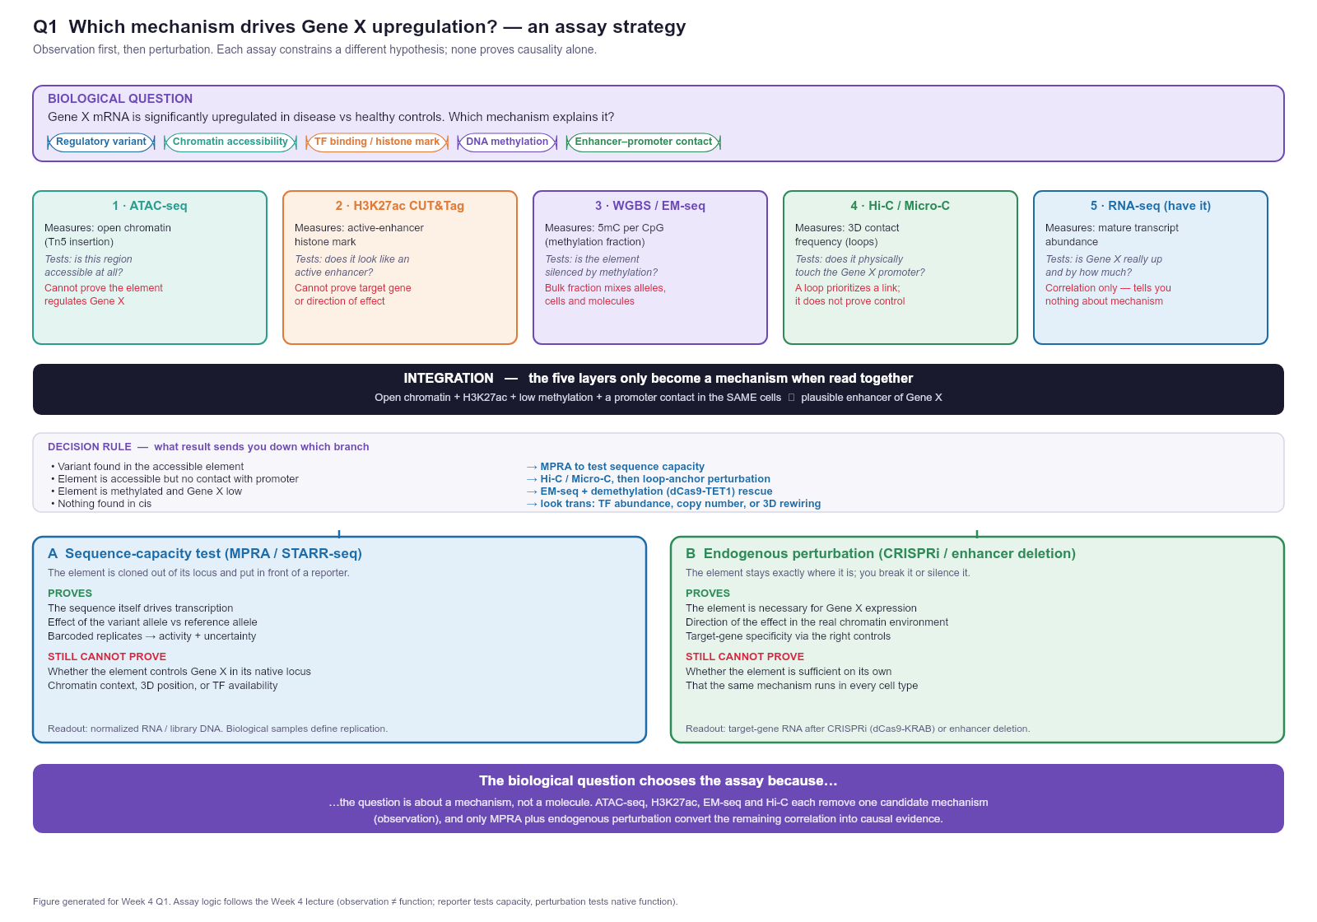
The biological question chooses the assay because the question is about a mechanism, not a molecule — so I select assays that discriminate between competing mechanisms in a deliberate order, rather than defaulting to the highest-resolution technology available.

Question 2 — From FASTQ to a Trustworthy Analysis Workflow (25 pts)

1. Reasoning before AI
I assumed the manifest's primary case (S01_CTRL_WGS / S02_CASE_WGS, WGS, paired-end) because WGS is the assay where the QC decisions have the most downstream consequences, and because the manifest contains multiple assays (WGS, RNA-seq, ATAC-seq, ChIP-seq H3K27ac) with matched case/control pairs — useful for showing that the same skeleton serves all of them.
Before asking AI for anything, I wrote out eight steps and, for each, what it is for and what would make me stop and go back:
Step | Purpose | Checkpoint / stop condition
1 FASTQ QC | Find adapter read-through, quality collapse, contamination, over-amplification | If adapter content is rising mid-read → trim and re-QC before alignment
2 Reference genome | Alignment is meaningless without a named build | Must state build and annotation release with a checksum
3 Alignment | Map reads to the reference | Mapping rate; a sudden low rate means wrong reference or contamination
4 Mapped-read processing | Remove duplicates, recalibrate base qualities | Duplicate rate appropriate to the assay (low for WGS, high for RNA-seq)
5 Assay-specific downstream | The same BAM means variants / counts / peaks / contacts | Choice of caller is assay-driven, not preference-driven
6 Annotation | Attach gene, consequence, frequency, clinical context | Annotation DB version must be recorded — it changes the answer
7 Visualization | Inspect the evidence, not just the summary statistic | Look at the pileup before trusting a FILTER flag
8 Interpretation | Turn evidence into a claim | Human judgement; this step is not delegable
My key pre-AI insight: QC is assay-relative. The same duplication number is alarming for WGS and normal for RNA-seq, so there is no universal "good" value — which is exactly why I do not accept an AI-provided threshold without knowing the assay.
FastQC metrics I chose to interpret (I read the snapshot in data/demo_fastq/fastqc_snapshot.tsv). Four are required; I interpreted six.
Metric | Snapshot value | My interpretation
Per base sequence quality | WARN — 3′ median Phred ~12 after cycle 50 on ~15% of R1 | A late-cycle quality crash. Phred 12 = ~6% base-call error, which is too high to align reliably at the read 3′ end. Because it affects only ~15% of reads late in the read, trimming the 3′ end (not discarding samples) is the right response. It also degrades variant calling specifically, since mismatches in low-quality tails create false-positive calls.
Adapter content | FAIL — AGATCGGAAGAGC rises at 3′ in ~15% of pairs | This is Illumina TruSeq adapter read-through: the insert was shorter than the read length. Adapter bases will mis-align or soft-clip, and adapter dimers waste depth. Action: adapter-trim, then re-run QC. This is the one FAIL that genuinely blocks downstream analysis.
Overrepresented sequences | FAIL — AGATCGGAAGAGC fragment among top overrepresented kmers | Consistent with adapter content (the two modules are two views of the same artefact). An overrepresented adapter sequence is explainable and fixable; an overrepresented unknown sequence would have suggested contamination and required a BLAST/lookup.
Per sequence GC content | WARN — main mode ~41% GC plus a high-GC shoulder (~78%) | A bimodal GC profile is the classic signature of a contaminant or a biased spike, not normal human WGS (~41% GC). ~10% of reads sit in the high-GC spike. I would quantify the spike and check it against a known high-GC organism rather than proceeding blind. This is a biology warning, not a chemistry one.
Sequence duplication levels | WARN — one template repeated in ~15% of R1 | For WGS, ~15% duplication is mild and largely expected from PCR plus low-complexity regions, so this is tolerable — but it must be marked (Picard MarkDuplicates) so duplicates do not inflate apparent depth and create false-positive variant support. For a targeted panel this would be a red flag; assay context decides.
Per base N content | PASS — N ~0% | No base-calling failure. Good: rising N mid-read would indicate a chemistry/instrument fault requiring a re-run, which no amount of trimming fixes.
The remaining snapshot modules (Sequence length distribution, PASS, all reads 80 bp) confirm the uniform synthetic read length and are consistent with a single-end-length library.
I also verified the demo FASTQ directly rather than trusting the manifest: both S01_CTRL_WGS_R1.fastq.gz and _R2.fastq.gz decompress cleanly and contain 120 reads of 80 bp each (4 lines per record: header / sequence / + / quality string), matching the manifest note.

2. AI-assisted workflow
I used a plan-first prompt, deliberately not "write me a pipeline":
- "Context: paired-end Illumina WGS of human samples, GRCh38, diploid germline variant discovery. Before writing any code: list the complete analysis stages from raw FASTQ to an annotated, filtered VCF. For each stage give the purpose, the tool, the key parameter and why, and the failure mode that would send me back a step. Also state what must be recorded for reproducibility."
- "Now for stage 1 only: given a FastQC report showing a 3′ quality crash on 15% of reads, adapter content rising at the 3′ end in 15% of pairs, a high-GC shoulder at ~78%, and 15% duplication, tell me which are fixable by trimming and which require re-running the library."
- "Give me the shell commands for the trimming and alignment steps, with version-pinned tool names."
AI-audit table (the submitted artefact):
AI recommendation | My verification | Final decision
"Align to hg19 because it is the most widely used human build." | Checked the NCBI assembly record: the current human reference is GRCh38.p14 (GCF_000001405.40). hg19/GRCh37 is the previous major assembly. | Rejected. Use GRCh38.p14 and name the annotation release. The choice must also match the annotation and any external frequency data, or coordinates silently disagree — the same trap the lecture's plan-first slide warns about ("No reference build specified").
"Trim all reads to 60 bp to clean up the 3′ end." | Interpreted the snapshot: the quality crash affects only ~15% of R1 after cycle 50, not the whole library. | Modified. Use quality-aware trimming (fastp / Trim Galore) that cuts adapters and low-quality tails per read, instead of a global hard trim that throws away good bases in 85% of reads.
"Filter variants with QUAL > 30 only." | Cross-checked against GATK's cohort-calling best practice (GVCF mode + joint genotyping); QUAL alone ignores depth, allele balance and strand bias. | Rejected as sufficient. Use VQSR where the cohort supports it, otherwise a documented hard-filter set (QD, FS, MQ, ReadPosRankSum), plus DP and allele-balance checks.
"Discard the sample because adapter content FAILed." | The adapter artefact is 3′ read-through affecting ~15% of pairs — a fixable library-prep artefact, not sample failure. | Rejected. Trim and re-QC. Discarding a sample would be data loss for no reason, and borderline "removing data to make results prettier".
"Call variants per sample and merge the VCFs." | GATK best practice is GVCF mode with joint genotyping so no-call evidence stays consistent across the cohort. | Accepted with correction. Per-sample gVCF, then joint genotyping — not merge of already-called VCFs.
"Use ComBat/sva to correct the batch now." | Batch correction applies to expression matrices; it is meaningless for a variant VCF, where the analogue is including batch in the association model. | Rejected as misapplied. Record batch in the sample metadata and model it at association time.

3. Verification
Checklist from the worksheet, completed:
- Genome build / annotation named explicitly — GRCh38.p14 (GCF_000001405.40) + a named GENCODE release. Verified against the NCBI assembly page.
- Formats correct for the tools — FASTQ (reads + Phred) → BAM/CRAM (aligned, coordinate-sorted, indexed) → gVCF (per-sample evidence) → VCF (cohort) → BED (0-based half-open intervals) / GTF (1-based). Verified against the Week 4 file-format table, which flags exactly these coordinate-convention differences.
- Software named with versions — FastQC 0.12.1, MultiQC, fastp/Trim Galore, BWA-MEM2, samtools, Picard/GATK BQSR, GATK HaplotypeCaller, Ensembl VEP, IGV, R/Bioconductor. Version-pinned because the lecture requires it and because caller/annotation version changes results.
- Parameters justified, not default-blind — trimming is quality-aware rather than a global hard trim; filtering uses a documented set rather than QUAL alone.
- At least one AI suggestion rejected or modified — five, listed in the audit table above (hg19, global trim, QUAL-only filter, discarding the sample, applying ComBat).
Sources checked: GATK Calling variants on cohorts of samples using the HaplotypeCaller in GVCF mode (https://gatk.broadinstitute.org/hc/en-us/articles/360035890411) for the gVCF + joint-genotyping recommendation; FastQC Analysis Modules documentation (https://www.bioinformatics.babraham.ac.uk/projects/fastqc/Help/3%20Analysis%20Modules/) for what each QC module actually measures; the NCBI GRCh38.p14 assembly record for the reference-build claim.

4. Final conclusion
Figure — figures/Q2_workflow.png
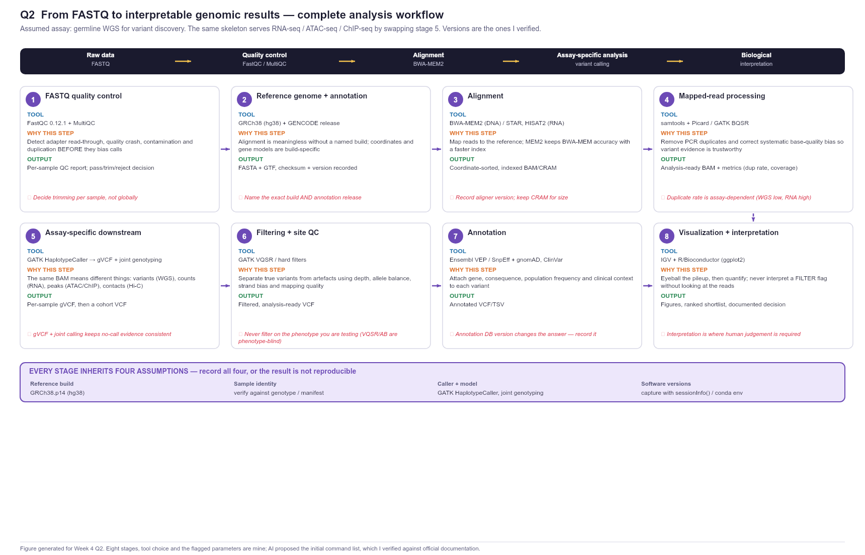
The final workflow has eight stages: (1) FastQC/MultiQC on raw FASTQ; (2) reference + annotation selection, GRCh38.p14 with a named GENCODE release; (3) alignment with BWA-MEM2 (STAR/HISAT2 for RNA); (4) mapped-read processing — duplicate marking and base-quality recalibration; (5) assay-specific downstream, which for WGS is GATK HaplotypeCaller in gVCF mode followed by joint genotyping; (6) filtering and site QC using depth, allele balance, strand bias and mapping quality rather than QUAL alone; (7) annotation with VEP plus gnomAD and ClinVar; (8) visualization in IGV and interpretation. Three decisions are mine and not the model's: I use GRCh38.p14 rather than hg19, I trim adapters and low-quality tails per read rather than truncating every read to a fixed length, and I keep MPRA-style sequence evidence distinct from endogenous functional evidence.
The analyst, not the AI, is responsible for the reference build and annotation version, the choice and justification of every threshold, the decision about which QC artefacts are fixable versus disqualifying, the distinction between a filter that removes artefact and a filter that removes inconvenient data, and the final interpretation — the model can propose commands and parameters, but it cannot know the assay context, and it cannot be accountable for a clinical claim.

Question 3 — Multi-Omics Regulatory Hypothesis (25 pts)

1. Reasoning before AI
I read each layer independently first, and wrote down what it directly shows before allowing myself to interpret anything.
Layer | Direct observation | Biological interpretation | Missing evidence
ATAC-seq | An accessibility peak overlaps the candidate region and the promoter; the candidate peak is present in this condition | The region is in open chromatin, so it is a plausible regulatory element rather than heterochromatin | Bulk signal cannot say which cells carry the open allele; no footprint analysis, so no TF is identified
H3K27ac | A broad H3K27ac domain spans the candidate region, with an additional domain at the promoter | The region carries an active-enhancer mark in this condition, consistent with an active enhancer rather than a poised or silenced element | H3K27ac marks activity, not target-gene specificity; no H3K4me1 to confirm enhancer identity, no H3K27me3 to exclude bivalency
Methylation | CpGs across the candidate region are hypomethylated (roughly 0.10–0.25 fraction) vs densely methylated flanks | The element is not methylation-silenced, so methylation is unlikely to explain a loss of Gene Y expression here | Bulk fraction conflates alleles, cells and molecules; no allele-specific methylation, no matched expression-methylation correlation
Hi-C / Micro-C | Elevated contact frequency between the candidate region and the Gene Y promoter, i.e. a loop | The element is in the same 3D regulatory neighbourhood as Gene Y, so it is a plausible cis regulator of that promoter rather than of a distant gene | Contact frequency is population-averaged across cells; no cell-type resolution; a loop does not establish direction or necessity
RNA-seq | Gene Y is expressed, and its transcript tracks the open/hypomethylated state | The locus is transcriptionally active, consistent with the element contributing to Gene Y output | Steady-state RNA cannot separate transcription rate from RNA stability; no allele-specific expression to link the element to one haplotype
Preliminary integrated model (before AI). Four of the five layers agree on the same picture: the candidate region is open, H3K27ac-marked, hypomethylated, and physically loops to the Gene Y promoter, while Gene Y is transcribed. The layers are concordant, which is exactly the situation where it is easiest to over-claim. My own concern is that every one of these five measurements is a correlation taken from the same bulk population, so convergence tells me the region is a strong candidate — it does not tell me the element is necessary. My open questions were: which TF actually occupies the element; whether the loop exists in the disease-relevant cell type or is an averaging artefact; and whether the H3K27ac domain belongs to this element or to a neighbouring one.

2. AI-assisted workflow
I asked the AI specifically to partition the evidence rather than to agree with me:
- "Here are five omics observations at one locus. For each, classify strictly into: (a) a direct observation from the data, (b) a biological interpretation, (c) missing evidence. Do not let interpretations leak into the observation column, and do not invent evidence."
- "Now propose the strongest ALTERNATIVE explanation for these data that does not require the candidate element to be an enhancer of Gene Y."
- "Design one functional experiment that distinguishes your alternative from my enhancer hypothesis, and state the expected result under each hypothesis plus the controls."
AI classification check — where I agreed and where I corrected it:
AI labelled as | Did I agree? | Correction
Observation: "the region is an active enhancer of Gene Y" | No | That is an interpretation, not an observation. The observations are peak present, H3K27ac enriched, CpGs hypomethylated, contact frequency elevated. I moved it to the interpretation column.
Interpretation: "H3K27ac proves active transcription of the element" | Partly | H3K27ac is associated with active regulatory elements; it does not prove transcription. I weakened the wording to "consistent with an active enhancer".
Missing evidence: "no Hi-C data" | No | We have Hi-C/Micro-C in this scenario. The correct missing-evidence items are allele-specific measurements, TF identity, and cell-type-resolved contact. I replaced it.
Missing evidence: "no perturbation of the element" | Yes | Correct and it is the decisive gap.
Alternative: "the region could be a promoter of an unannotated transcript, not an enhancer of Gene Y" | Yes — I adopted this as my alternative | Genuinely distinct from my hypothesis and fully consistent with open chromatin + H3K27ac + contact with a nearby promoter.

3. Verification
- I checked the mark-to-function assignments against the Week 4 lecture's histone-modification reference (H3K27ac = active enhancers/promoters; H3K4me3 = active promoters; H3K27me3 = repressed) rather than trusting the model's labels.
- I checked the claim that a methylation fraction is ambiguous by construction against the lecture's DNA-methylation slide, which explicitly states that a bulk fraction summarises molecules, alleles and cells. This is why I list allele-specific methylation as missing evidence instead of treating the bulk value as conclusive.
- I checked the two-step logic "observation ≠ function / perturb to establish causality" against the lecture's From regulatory clues to functional proof slide, which also warns that "MPRA measures regulatory capacity not necessarily endogenous function". This is what made me insist on both an MPRA and an endogenous perturbation.
- I verified that Hi-C/Micro-C resolution is a genuine caveat for a single element using the lecture's own resolution figures (1–5 kb at high depth), so population-average contact must not be over-read.

4. Final conclusion
Observations vs interpretations vs missing evidence — the table above is my final partition.
Alternative explanation. The candidate region is not an enhancer of Gene Y at all, but the promoter or first exon of an unannotated transcript (or a long non-coding RNA) that happens to sit upstream of Gene Y. Under this model everything observed is still expected: it is open chromatin (promoters are), it is H3K27ac-marked (active promoters are), its CpGs are hypomethylated (active promoters are), and it makes 3D contact with the Gene Y promoter (two adjacent promoters on the same topologically associating domain contact each other). The correlation with Gene Y expression would then be a consequence of shared regulatory input, not of enhancer activity. A second, weaker alternative is that the H3K27ac domain belongs to a neighbouring element and the candidate region is merely bystander open chromatin.
Functional experiment (correlation vs causality). I would run CRISPRi (dCas9-KRAB) with guide RNAs tiling the candidate element, in the disease-relevant cell type, plus an MPRA as the sequence-capacity control.
Field | Answer
Experiment type | CRISPRi (dCas9-KRAB) at the native locus, with an MPRA in parallel
What is perturbed | The candidate element's chromatin (CRISPRi) and its sequence in isolation (MPRA)
Expected if enhancer is causal | CRISPRi → Gene Y RNA falls; MPRA → the element drives reporter activity, and the disease allele differs from the reference allele
Expected if alternative is true | CRISPRi → Gene Y RNA unchanged (silencing a neighbouring promoter does not silence Gene Y); MPRA → activity reflects promoter-like, not enhancer-like, behaviour. If the region is an independent promoter, CRISPRi reduces that transcript, which I would detect by targeted RNA assay
Key controls | Non-targeting guide RNA; guides against a known Gene Y enhancer (positive control) and against a neutral intergenic region (negative control); MPRA with a minimal promoter alone and with a known strong enhancer; allele-swap controls in the MPRA; ≥3 biological replicates, with technical barcodes explicitly not counted as replicates
~200-word integrated interpretation.
At this locus the five layers converge: the candidate region is accessible, carries a broad H3K27ac domain, is hypomethylated at its CpGs, makes elevated 3D contact with the Gene Y promoter, and Gene Y is transcribed in the same condition. Read together, the layers are strongly consistent with a cell-type-specific enhancer that loops to the Gene Y promoter and sustains its transcription, and each assay compensates for a specific blind spot in the others: accessibility shows the region is available, H3K27ac shows it is in an active rather than repressed state, methylation excludes silencing as the explanation, 3D contact supplies the physical link to Gene Y that the one-dimensional assays cannot provide, and RNA-seq confirms the transcriptional output that the question is about. The critical limitation is that all five are population-averaged correlations measured in the same bulk samples, so their agreement raises confidence in the candidate but provides no evidence of necessity; the alternative that the region is an unannotated promoter rather than an enhancer of Gene Y predicts the same observations. Only perturbation of the native locus, with an MPRA as the sequence-capacity control, separates these possibilities.
Figure — figures/Q3_locus_chain.png
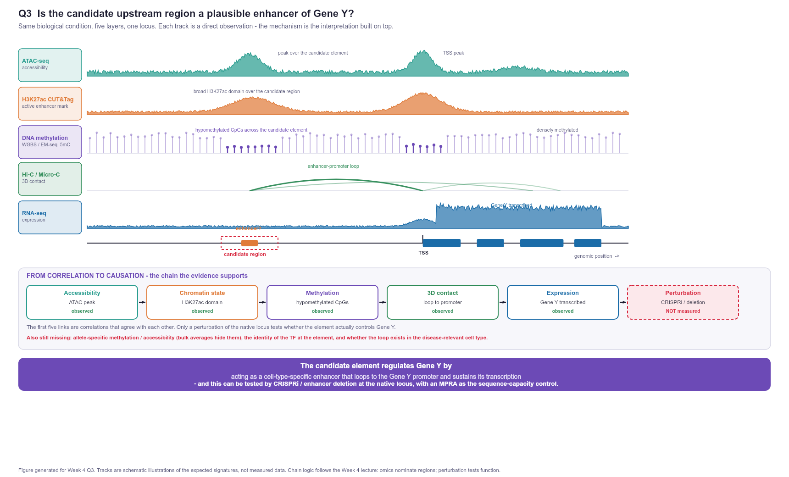
The candidate element regulates Gene Y by acting as a cell-type-specific enhancer that loops to the Gene Y promoter and sustains its transcription , and this can be tested by CRISPRi / enhancer deletion at the native locus (with allele-resolved MPRA as the sequence-capacity control).

Question 4 — Variant Prioritization (25 pts)
Data-safety note. data/variants_q4.tsv is explicitly synthetic teaching data: positions, gene names and ClinVar-style IDs are illustrative. Nothing below is a clinical interpretation and none of it should be entered into a clinical database. I treat the exercise as a method demonstration.

1. Reasoning before AI
I wrote my filtering logic and thresholds before asking for code, because the lecture's plan-first slide is right that a vague prompt produces risky code, and because the thresholds are scientific decisions rather than coding decisions.
Criterion | My rule | Rationale
FILTER | Hard exclude anything not PASS | A non-PASS call is a known technical artefact; interpreting it is a category error
Depth (DP) | Hard exclude DP < 20 | Below ~20 reads, allele balance and genotype likelihoods are unreliable, and a het can be missed by chance
Genotype quality (GQ) | Hard exclude GQ < 30 | GQ 30 = a 1-in-1000 chance the genotype is wrong (Phred scale); lower values make the call itself uncertain
Allele frequency (AF) | Hard exclude AF > 0.01 | A variant above 1% in the population is too common to be the sole cause of a rare phenotype (this is the standard rare-disease reasoning used in ACMG/AMP criteria such as BA1/BS1)
Consequence | Keep splice acceptor/donor, stop-gained, frameshift, start-lost, missense | These are the classes that can plausibly change protein or transcript integrity; splice site and nonsense/frameshift changes are the ones that map to the ACMG PVS1 "predicted null" category
ClinVar / clinical annotation | Soft rank, not hard filter | Pathogenic/Conflicting/VUS rank higher, and Likely_benign/Benign rank lower — but I do not delete a variant on the basis of a label in a table whose IDs are synthetic
Gene / biology relevance | Soft rank (gene symbol assigned, no ".") | A variant with no gene assignment cannot be linked to a phenotype without extra work
Hard excludes (always drop): FILTER != PASS; DP < 20; GQ < 30; AF > 0.01. Soft ranks (keep but down-weight): ClinVar label; consequence class; rarity within the rare band; call quality above the floor.
My expectation before running anything: the deliberately planted quality traps should fall out on the technical filters (MSH2 LowQual/DP=8/GQ=12, MECP2 DP=5/GQ=20, HLA-A FILTER=FAIL), the common polymorphisms should fall out on AF (F5 0.42, ATM 0.18, the intronic 0.35), and a handful of rare impactful variants should survive with TP53 and BRCA2 near the top.

2. AI-assisted workflow
I used a plan-first prompt, then had AI write code against my thresholds:
- "Context: GRCh38 diploid germline variant table, synthetic teaching data. Columns: CHROM, POS, REF, ALT, FILTER, DP, GQ, AF, GENE, CONSEQUENCE, CLINVAR_SIG, CLINVAR_ID, NOTE. Before coding: list the checks, my filtering logic, how to report row counts at every stage, and what could go wrong."
- "Now write commented R that implements these exact thresholds (FILTER=PASS, DP>=20, GQ>=30, AF<=0.01, impact consequences only), preserves the raw file, prints the filter cascade, and records sessionInfo(). State that the result is not a diagnosis."
- "Why might the top variant be a false lead? Give me the strongest arguments, not reassurance."
The code is analysis/q4_prioritize.R; the full console output is analysis/q4_out/q4_run_log.txt. Two things I insisted on and one bug I caught: the script writes a copy of the raw table before any transformation (the lecture's "preserve the raw file" guardrail), it prints a before/after count for every filter, and I found and fixed a genuine R operator-precedence bug of my own — CONSEQUENCE %in% IMPACT & FILTER == "PASS" parses as %in%(CONSEQUENCE, IMPACT & FILTER == "PASS"), which silently produced a nonsense sensitivity set, so every condition is now explicitly parenthesised.
My filter cascade (real output):
Step | Rule | Variants before | After | Dropped
1 | FILTER == PASS | 12 | 10 | 2 — MSH2 (LowQual), HLA-A (FAIL)
2 | DP >= 20 | 10 | 9 | 1 — MECP2 (DP=5)
3 | GQ >= 30 | 9 | 9 | 0 (MECP2 already gone)
4 | AF <= 0.01 | 9 | 6 | 3 — F5 (0.42), ATM (0.18), intronic (0.35)
5 | impactful consequence | 6 | 4 | 2 — CFTR (synonymous), intergenic
4 variants survive. Ranked by my transparent additive score (ClinVar weight + consequence weight + rarity + call quality; weights in the script and in the figure):
Rank | Gene | Variant | Consequence | ClinVar-style | AF | DP | GQ | Score
1 | TP53 | chr17:7673803 G>A | splice_acceptor_variant | Pathogenic | 1e-05 | 80 | 99 | 15
2 | KRAS | chr12:25398284 C>A | missense_variant | Conflicting | 1.5e-04 | 58 | 91 | 9
3 | BRCA2 | chr13:32316461 C>T | missense_variant | Uncertain_significance | 1e-04 | 60 | 90 | 8
4 | LDLR | chr19:11200200 C>T | missense_variant | Likely_benign | 2e-04 | 40 | 88 | 6
Sensitivity check. Tightening AF <= 1e-4 and DP >= 30 leaves 2 variants: TP53 and BRCA2. So TP53 is robust to the stricter filter, while the 2nd pick is not stable — KRAS drops out and BRCA2 replaces it. I therefore report TP53 as the single top pick and treat the second slot as BRCA2, not KRAS, under a conservative threshold.

3. Verification
Claim to verify | Resource checked | Result
Splice-acceptor variants are treated as a predicted-null (high-impact) class | ACMG/AMP criteria as summarised in ClinGen variant-curation guidance (PVS1 = predicted null: nonsense, frameshift, canonical ±1 or 2 splice sites) | Confirmed. The TP53 call sits in the canonical splice-acceptor class that PVS1 is designed for — if the coordinate and annotation were real.
Consequence vocabulary used (splice_acceptor_variant, missense_variant, synonymous_variant, intron_variant, intergenic_variant) | Ensembl VEP sequence-ontology consequence terms (VEP documentation) | Confirmed as valid SO terms; this matters because my filter keys off the exact strings.
A population-frequency ceiling is a legitimate filter for a rare phenotype | gnomAD-style frequency reasoning as applied in ACMG/AMP (BA1/BS1 stand-alone/strong benign at high frequency) | Confirmed in principle. The AF values here are synthetic, so the threshold (1%) is defensible but the numbers cannot be checked against gnomAD.
The ClinVar-style IDs are real ClinVar records | Attempted interpretation against ClinVar/ClinGen | Could NOT verify — and this is the important negative result. VCV000012345, VCV000067890, VCV000000111, etc. are teaching placeholders, and the data README states the table is fictional. I therefore refuse to treat any CLINVAR_SIG value as clinical evidence, and it stays a soft rank rather than a hard filter.
Reference build | NCBI assembly record: current human reference is GRCh38.p14 (GCF_000001405.40) | Confirmed. Also the source of my false-lead concern below: chr12:25398284 is a GRCh37-era KRAS coordinate, which is internally inconsistent with a GRCh38 table and reinforces that coordinates here are illustrative.
Sources checked (≥2): ClinGen variant-curation / ACMG-AMP criteria specifications (https://submit.ncbi.nlm.nih.gov/api/2.0/files/o5ekfuov/clingen_variant_curation_sop_v3.2_classification_guidance_july2025.pdf), Ensembl VEP script and consequence documentation (http://oct2024.archive.ensembl.org/info/docs/tools/vep/script/VEP_script_documentation.pdf), NCBI GRCh38.p14 assembly record (https://www.ncbi.nlm.nih.gov/datasets/genome/GCF_000001405.40/), plus the data README's own statement that the table is synthetic.

4. Final conclusion
Top pick: TP53 chr17:7673803 G>A (splice_acceptor_variant). Second slot: BRCA2 chr13:32316461 C>T (missense, VUS) — not KRAS, which is the nominal score rank 2 but is displaced under a stricter AF threshold.
False-lead critique. Asking the AI "why is my top variant a false lead?" produced the arguments in figures/Q4_prioritization.png. I judged them as follows:
Concern | Scientifically important? | Why
Coordinates/IDs are synthetic | Yes — decisive for how I report | Nothing can be presented as a clinical finding. This is a methods exercise.
splice_acceptor_variant is a prediction, not a measurement | Yes — decisive | The consequence is annotation-derived. Only RT-PCR across the junction (or a minigene) shows the splice is actually broken and that the transcript is out of frame.
No phenotype, inheritance model or segregation data | Yes | Without it, "Pathogenic" cannot be attached to this patient; PVS1 alone does not make a variant causal.
Single-call evidence, no orthogonal confirmation | Yes | One caller at DP=80 with no Sanger confirmation and no check that the second allele is covered; a mis-mapped or mis-called site would look identical.
Build ambiguity (chr12:25398284 looks GRCh37-style) | Yes, but secondary | It mainly tells me the table is illustrative; still, it is the reason every coordinate must be build-qualified before comparison.
"The score is subjective / weights are arbitrary" | Partially | True, but the fix is transparency, not a different formula: every weight is stated and the sensitivity check shows which conclusions depend on them. That is why I report the instability of rank 2.
Concerns I accept as remaining risk: the variant's effect on splicing is unproven, the clinical significance is unverifiable in synthetic data, and no functional or segregation evidence exists. These are exactly what the required experiment addresses.
~200-word interpretation — known evidence → computational inference → scientific hypothesis → required experiment.
Known evidence. The variant is a rare (AF = 1e-05), high-quality (DP = 80, GQ = 99, PASS) substitution at chr17:7673803 G>A annotated as a canonical splice-acceptor change in TP53, with a ClinVar-style Pathogenic label. Computational inference. Because splice-acceptor disruption typically abolishes the canonical acceptor and forces use of a cryptic site or exon skipping, and because such changes fall in the ACMG predicted-null (PVS1) category, this is the most likely of the 12 calls to produce a genuinely loss-of-function allele; its low population frequency is compatible with a rare-disease role. Scientific hypothesis. This variant impairs correct splicing of TP53, reducing functional p53 activity and thereby contributing to the phenotype. Required experiment. RNA-based confirmation first: RT-PCR across the affected exon junction on patient RNA, plus a minigene reporter carrying the variant allele, to demonstrate exon skipping or cryptic-site usage and the resulting frameshift; then Sanger confirmation of the genomic call, and segregation in available family members. Only then does a functional (e.g. p53-response) assay become worth running.
Figure — figures/Q4_prioritization.png
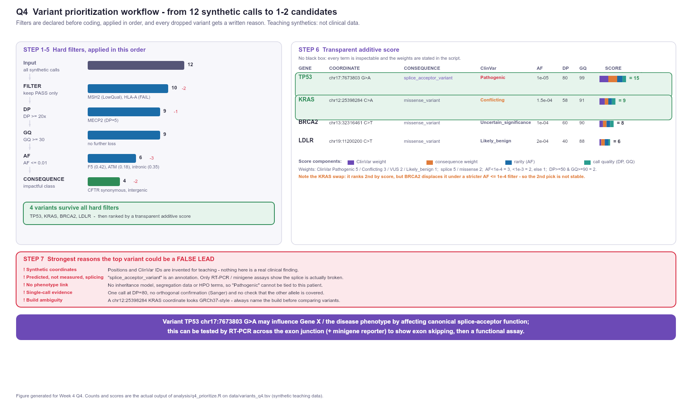
Variant TP53 chr17:7673803 G>A may influence the disease phenotype by affecting canonical splice-acceptor function and therefore TP53 transcript integrity; this can be tested by RT-PCR across the exon junction plus a minigene reporter to demonstrate exon skipping, followed by Sanger confirmation and segregation analysis.

Appendix

Prompts used (abbreviated)
# | Question | Prompt
1 | Q1 | "Critique this assay ordering for distinguishing 5 mechanisms behind Gene X upregulation… Where is it wrong?"
2 | Q1 | "For each assay, state what it measures and one thing it CANNOT prove. Be strict about correlation vs function."
3 | Q1 | "What mechanism would my six-assay plan still miss entirely?"
4 | Q2 | "Plan first: list stages FASTQ→annotated VCF with purpose, tool, key parameter and failure mode."
5 | Q2 | "Which FastQC findings are fixable by trimming and which require re-running the library?"
6 | Q3 | "Classify each of these five omics observations strictly as observation / interpretation / missing evidence."
7 | Q3 | "Propose the strongest alternative explanation that does not require this element to be an enhancer of Gene Y."
8 | Q4 | "Plan first: checks, filtering logic, row counts at every stage, and what could go wrong."
9 | Q4 | "Why might the top variant be a false lead? Give the strongest arguments, not reassurance."

Code and filter thresholds
- analysis/q4_prioritize.R — the Q4 pipeline (thresholds: PASS, DP>=20, GQ>=30, AF<=0.01, impact consequences; score weights documented in the file).
- analysis/q4_out/ — q4_run_log.txt (full console output), q4_filter_cascade.tsv, q4_ranked_shortlist.tsv, q4_excluded.tsv, variants_raw_copy.tsv, sessionInfo.txt.
- analysis/fig_*.js — figure generation scripts; analysis/lib/draw.js — shared drawing helpers.
- Excel-style filter cascade and the scored shortlist are also embedded in figures/Q4_prioritization.png.

Extra figures
File | Contents
figures/Q1_workflow.png | Assay strategy: question → five observational assays → integration → decision rules → two functional-validation arms
figures/Q2_workflow.png | Eight-stage FASTQ→interpretation workflow with tool, purpose, output and flagged parameters
figures/Q3_locus_chain.png | Integrated locus view with five tracks plus the accessibility→chromatin→methylation→3D→expression→perturbation chain
figures/Q4_prioritization.png | Filter cascade, scored shortlist with component breakdown, false-lead critique, final hypothesis

Reproducibility
- Week 4 lecture deck read slide-by-slide (Genomics — Sequencing, Variant Interpretation, and AI-Assisted Analysis-Week 4.pdf, 41 slides) and used as the primary internal reference; all figure logic traces to it.
- Q4 numbers reproduced with R 4.6.1 via Rscript analysis/q4_prioritize.R; sessionInfo() recorded.
- Figure scripts are deterministic (fixed pseudo-random seeds), so the PNGs regenerate byte-identically.
- Data used are the synthetic teaching files only; no real patient data were accessed.

